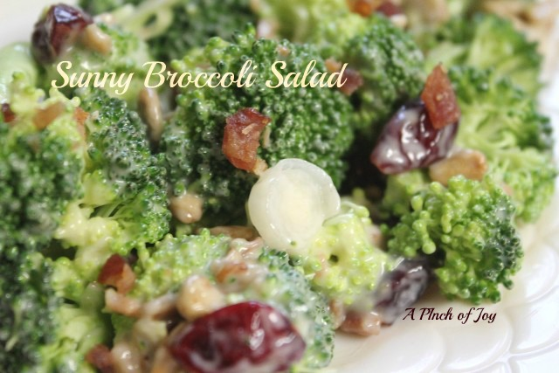
Sunny Broccoli Salad
2 cups fresh broccoli, approx 1 medium head
3 bacon strips, cooked and crumbled
1 green onion, thinly sliced
3 Tablespoons golden raisins or craisins
1 Tablespoon salted sunflower seeds
Dressing
1/3 c olive oil mayonnaise
4 teaspoons sugar
2 teaspoons white vinegar

Break florets apart and/ or slice broccoli into small pieces
In a bowl, combine the broccoli, bacon, onion, raisins and sunflower kernels.
In a small bowl, combine the dressing ingredients; stir until smooth.
Pour over broccoli mixture and toss gently.
Cover and refrigerate for at least 2 hours before serving, stirring occasionally.
~~~

This recipe comes from a wonderful cook in Missouri. I led a group of volunteers, 10 adults and 21 teens, to Ste. Genevieve, Missouri where we did repair following a flood. The days were long, hot and sweaty, and everyone worked hard. Millie had a fantastic meal waiting for us each night when we returned to the church basement where we were staying. When I saw her mixing up this salad one afternoon, I thought “uh-oh, those kids will never eat this.” They did and came back for more. It is that good!
Millie gave me the recipe and a piece of advice. Approaching her eighth decade of life, her days were amazingly productive. She told me: slow and steady – don’t ever rush. You never get things done right and you just wear yourself out. Just know what you need to get done during the day and keep moving that direction. That motto is as valuable as the broccoli salad!
Charlene @ A Pinch of Joy http://www.apinchofjoy.com

